Customer Information for

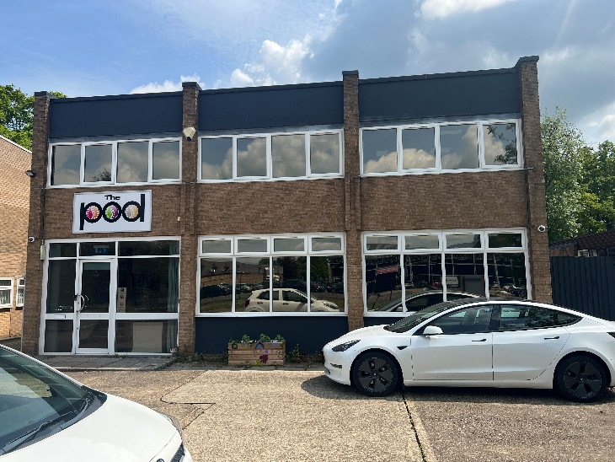
This is our head office in Moulton Park.
You are welcome to visit us!

INDEX
How to contact us  About us  Where you live  Staff & management  Our support  Compliments & complaints  What next? | PAGE  4  5  7 & 8  9  10 & 11  12  13

How to contact us

PHONE US!!
01604 307758
or
07793 217922

EMAIL US!!
headoffice@completesupportcareservices.co.uk

WRITE TO US!!
The Pod, 4 Pond Wood Close,
Moulton Park,
NN3 6RT

VISIT OUR WEBSITE!!
www.completesupportcareservices.co.uk

VISIT US ON SOCIAL MEDIA
Facebook

About us
Complete Support Care Services Ltd is a supported living and day service provider in Northampton. This means we send staff to help people with learning disabilities to do every day things in their own home and out in the community. The aim of our service is to provide treatment and continuing support for people who have mild to severe learning and/or physical disabilities.
“Treatment” means we are meeting your health, cultural, personal, behavioural, nutritional needs (and lots more!)
“Continuing Support” means that we will assist you in maximising your abilities and become as independent as possible, learning independent living skills, accessing education and finding employment.
We will be your advocates – this means we will support you to share your thoughts and feelings about things that effect you, like choosing where you live, who supports you and how they do this.
In January 2020 we were inspected for the first time by CQC who rated us GOOD!
The company is owned by two people. Daniel Duggan is one and he is also the registered manager. This means he has to make a lot of important decisions to make sure you are happy, safe and healthy. He has worked with people with learning disabilities since the year 2000!! So, he has a lot of experience. He has also worked hard to get a qualification which allows him to manage a service like this one. He has a Diploma Level 4 in Leadership & Management as well as an NVQ 3 in Health & Social Care. |  | Daniel
Brie | The other owner is Daniel’s wife, Brie Duggan. Brie works in the office, making sure that only the very best staff are given a job to support you. She checks their background to make sure that they will do a good job Brie also checks that you have an up to date care plan and that any paperwork is completed properly. She has done this job since 2004!

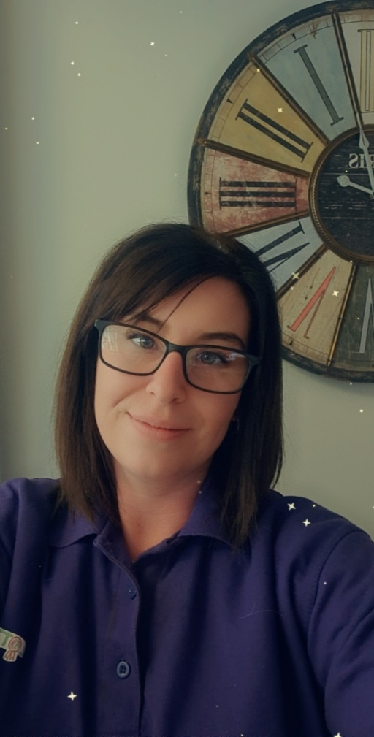  Leah | We also have a deputy manager, Leah Durkin, who helps Daniel and Brie across the whole company. She helps a lot with everything relating to health, like medication and different medical appointments. Leah has a great relationship with the team, customers and external health and social care professionals – if you every need anything, Leah can get it!  Leah also helps with being on call when Daniel & Brie are having a break. Soon Leah will become a registered manager for the company as she is about to pass her level 5 in Leadership and Management Diploma.

  Sammie | Sammie is the manager for our Day Services. She helps run both services - The Pod and Lotties Yard. Sammie is very creative and thinks up some amazing activities with your likes and your abilities at the heart of them!  At The Pod you can do lots of different activities like yoga, pool and bingo. These is also a sensory room there you can relax in. Lottie's Yard is in Boughton village and is all about animals and being outdoors. We have 4 horses and 3 shetland ponies there along with some rabbits and guinea pigs.

Where you live
You get to choose where you live. Our service covers the Northampton area which is a great place to live! It is a large town with lots of things to do and a good transport system so you can travel independently or with a member of your support team.
These are a few of the places you can visit and services available to you. If you want more information just ask!

SHOPS
Your nearest supermarket is Tesco, Weston Favell. This is a big shopping centre with lots of other shops. Ask your support team to take you if you haven’t been or need support.
There is a big retail park 2 miles away. It is called Riverside. There are several different types of stores there, including NEXT, Sports Direct, Boots and Homebase, to name but a few! As well as fast food and sit down eateries.

PARKS
There are lots of fantastic parks and nature reserves in and around Northampton. Your support team will make arrangements throughout the summer months for picnics and barbecues.

SALON
There is a hair and beauty salon on Boothville Green called Katie Louise. The staff in this salon are very attentive and kind and if you are male or female and looking for a salon experience, we highly recommend this place to you!
Weave & Style Lounge, 2 Boothville Green, Northampton, NN3 6JR
Tel: 01604 945976

RESTAURANTS
There are so many restaurants in Northampton!! A lovely one that is near to you is The Trumpet and also the Lumbertubs! These are gastro style pubs. They have great facilities and friendly teams. You and your housemates will have the chance to go there lots of times if you wish. If you want to try other cuisine, speak to your support team about the restaurants available.

CINEMA
 | We have 3 cinemas in Northampton. The closest is at Lings Forum, which is next to Weston Favell Shopping Centre. But it is quite a small cinema. The bigger cinemas are further in to the town centre. Speak to your support team to make arrangements.
Sol Centre Northampton  Doddridge Street  Northampton  NN1 2RN  0345 308 4620 |  | Sixfields Leisure  Weedon Road  Northampton  NN5 5QJ  0871 200 2000 | Lings Forum  Weston Favell Centre  Billing Brook Road  Northampton  NN3 8JR  01604 837300

SWIMMING POOLS
There is a swimming pool at Lings Forum, which is the closest one to you. However, if you require extra physical support, this pool wont be suitable. Disabled facilities can be found at Danes Camp Swimming Pool and there is a Hydro-Therapy Pool in Moulton. |  |  | 
Danes Camp  Clannel Road  Northampton  NN4 0RX  01604 837200 | Lings Forum  Weston Favell Centre  Billing Brook Road  Northampton  NN3 8JR  01604 837300 | Moulton College  Gate 4  Pitsford Road  Moulton  NN3 7QL  01604 492222

BOWLING
Northampton has a bowling alley on the other side of town which is very lively and popular. It is near to the cinema and lots of restaurants, so you can make the most of being there! |  | 
Sixfields Leisure, Weedon Road, Northampton, NN5 5QL
Tel. 0871 222 3675

NIGHT LIFE
 | Northampton has a thriving night life for able and disabled bodied people. There are organisations and pubs/clubs which arrange and host evenings out. Your staff team will support you to know what is on and how to get there!
This is organized by “Care with a Difference” every Thursday evening from 7pm!  Bridge Street, Northampton  NN1 1PF  01604 638401 |  | These evenings take place throughout the year. Go on the website to find out when the next one is!  www.rockinroadrunner.com  The New Roadmender, 1 Lady’s Lane  Northampton, NN1 3AH

Staff & Management
Our dedicated support team are here for you. If you have any needs or any questions, they will be happy to help you. All of our staff have an enhanced DBS disclosure and a minimum of x2 references, one is from their last job. We find out as much about them as possible to make sure that they are going to be the right people for the job!
Some of the team do different roles. Here are the current staff team and their roles:

THE REGISTERED MANAGER
This person is in charge of the team and makes sure your home and support make you happy. |  | YOU MET DANIEL EARLIER IN THE SECTION “ABOUT US”!
 | Daniel | YOU MET DANIEL EARLIER IN THE SECTION “ABOUT US”!

 |  | HOUSE LEADERS
The house you live in will have a dedicated house leader. This person works at your house a lot and is in charge of making sure everything runs smoothly. They help the other staff know how to support you and will work closely with Daniel to make sure you are happy
 | 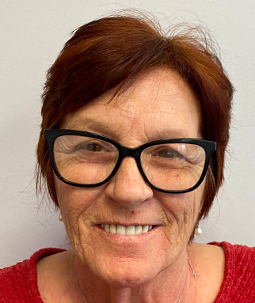 |  |  | 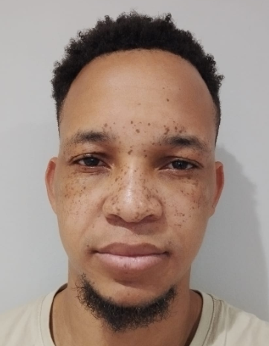 |  |  |  | 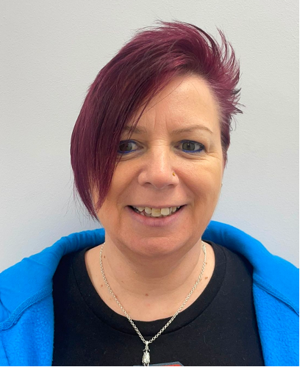
 | Kate |  |  | Noel |  | Ashel |  | Gina

THE SUPPORT TEAM
These are some of the dedicated people who support you to be as independent as possible and live a good life. One of these people could become your own personal key worker and help you to achieve in your life.
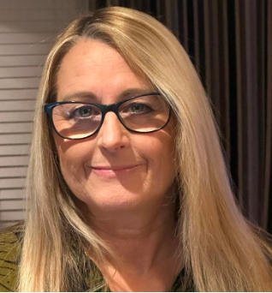 |  | 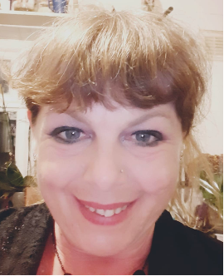 |  | 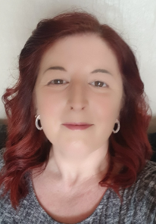 |  | 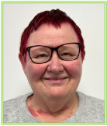 |  |  |  |  |  | 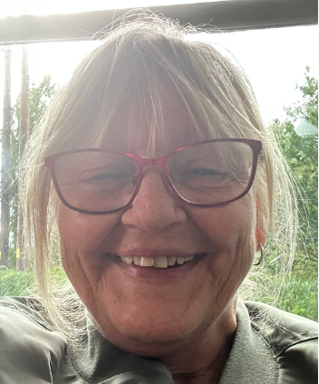
Kerri |  | Maria |  | Sue H |  | Sheila |  | Amitha |  | Chelsea |  | Sue J

We want our team to be kind, caring and trained to do the very best job for you. We train our staff on lots of different subjects, like first aid, food hygiene, fire safety, health & safety, medication, moving & handling, equal opportunities, safeguarding, mental capacity act and deprivation of liberty safeguards. If you have any specific needs, such as you are epileptic or diabetic, we will ensure the team are specially trained for you.
We care a lot about our staff, so we meet with them to talk about how we can support them to do their jobs better and thank them for the things they do well. We want you to be a part of these meetings. We will also invite you to help us with interviewing new staff members. After all, you will be being supported by them, so you should get to choose who gets the job. You will be asked what you think of new staff after they have started work as well. What you think of our staff is really important to us

Our Support
…..is personalised to you! Before you choose us as your supported living provider we will meet with you and talk about what you want. We will then work hard to build a care plan that meets your needs and wants. This is a folder that you keep at home which holds all the information staff need to know in order to keep you safe and make you happy.
These are some of the things we can do to support you to live a happy, healthy and safe life

Washing & Styling your hair. | PERSONAL CARE  If you need help with personal care tasks, we can make sure you are supported in a private place and always treated with dignity. You get to choose who helps you with this and how they help you. | Using the toilet
Choosing your outfits |  | Showering & Bathing
  Hair removal |  | Looking your best!

Shopping | INDEPENDENCE  We will promote your independence at every opportunity, no matter how far your abilities reach or what needs you have. You will be encouraged and supported to do lots of things for yourself and be fully present and involved in anything you need full support with. | Household Chores
Cooking |  | Managing Money
Dressing & Undressing |  | Taking Medication

Spending your Money | FINANCES  If you want or need us to we will help you learn, to the best of your ability, how to manage your personal monies; claim any benefits, access your bank, save money and pay your household bills, while keeping an accurate detailed record of all transactions for your personal information. | Accessing your Money
Budgeting |  | Keeping your Money Safe
 | Your Income

We can support you to get back in to education. | LEARNING  We are here to help you to learn and develop new skills, so you can enjoy more life experiences and achievements. There are lots of ways you can learn which can help you to secure a job as well! Your team will support you to complete a weekly Achievement & Development Diary which will help you to set goals and make plans to reach them! | Learn about the world
Learn to use a computer and the internet |  | Get a qualification
Learn a new skill |  |   Join a library

Relationships | Family & Friends  We will support you to stay in contact with the people you care about and who you choose. Your friends and family will be welcomed by us and can be as involved in your care and treatment as you want them to be. | Socialising
  Community |  | Family
Care Planning |  | Circle of Support

GP | Healthcare & Support  Your health is really important to us and you might need help to make sure you see your GP and other healthcare professionals regularly and when you need to. You will have a dedicated section in your care plan relating to your health so you can keep track on everything!  We will also help you with your medication. | Podiatrist
Optician |  | Psychiatrist/Psychologist
Dentist |  | Medication & being poorly

Horses | Do the things you love <3  We will support you to build a bucket list and achieve everything you have ever dreamed of! And also support you in doing the hobbies you love and exploring new ones. | Cycling
Car racing |  | Relaxing!
Fun Fair | Cruises & Boats | Trains

COMPLIMENTS & COMPLAINTS
WE WANT TO HEAR FROM YOU!
What you think about our service is really important to us. YOU are important to us! So, whether you want to tell us something that has made you happy OR if there is anything you are unhappy about – we want to know!

You will be given some leaflets when you move in – more are available upon request for you to either fill out in private, or with the support of a team member. Your complaint can be sent to –
The Pod
4 Pond Wood Close
Moulton Park
Northampton
NN3 6RT
Or you can call 01604 307758
 |  | We will write to you within 7 days of you making a complaint with information about what we have or are going to do about it.
If you are unhappy with how we have dealt with your complaint, you can approach –
West Northamptonshire Adult Social Services
One Angel Square
4 Angel Street
Northampton
NN1 1ED
Or you can call 0300 126 7000
🤩  VIP | We also give out yearly questionnaires which help us know what we are doing well at and any areas that we need to do better in. Head Office will send these to you, usually in April each year.

What you think about us and how you feel is very important.

TELL US WHAT YOU THINK!

🤔

What’s next?
If you are interested in being supported by Complete Support Care Services Ltd, we can make arrangements for you to visit some of the other people we support and get some of our staff to spend time with you.

We will complete an assessment of your choices and needs and see if we are the right service for you! We will always be honest if we don’t think we can meet your needs and can recommend some other great services who could support you better.

If you have any questions, you can contact us using the details on page 4 of this brochure in the section named “How to contact us”.
🤗
We hope to hear from you soon!!

